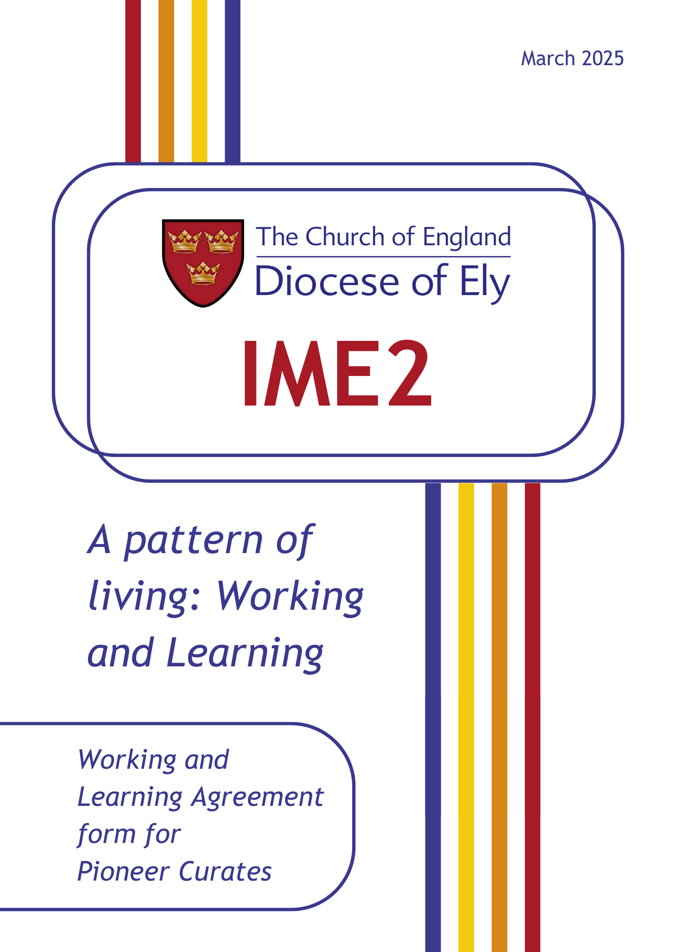

**A Pattern of Living:**

**Working & Learning Agreement**

**Details of Title Post**

|  |  |
| --- | --- |
| Name of Pioneer Curate |  |
| Name of Training Incumbent |  |
| Benefice/Parish/BMO Area |  |
| Mode of ministry (please tick) | □ Stip full-time □ Stip part-time □ Self-supporting |

The period of Title, which begins with ordination to the diaconate, will normally be five years for pioneer curates.

|  |  |
| --- | --- |
| Starting date of training post |  |
| Review date |  |
| Expected end date of training |  |

Notes:

a. There will be a review at the end of year 2 to determine whether the curacy will continue beyond year 3.

b. If a curate wishes to move to a new post before the end of three years, the bishop’s permission must be sought (after initial consultation with the Training Incumbent and the Director of Mission and Ministry) before any application is made.

c. The normal period of notice is three months.

Note for action:A draft copy of this Working and Learning Agreement is to be returned to the Clergy Development Officer **no later than three months** after ordination. This document is kept on file by the TI, Pioneer Curate, and Ordained Ministry Team in the diocese, and it forms part of the basis for periodic review.

For more advice in filling out this agreement you can contact the Clergy Development Officer: steven.rothwell@elydiocese.org.

Pattern of Living: Working and Learning Agreement

This is the ‘learning agreement’ referred to in your Statement of Particulars.

The *Pattern of Living: Working and Learning Agreement* form is drawn up at the start of a curacy between training incumbent and curate and provides an initial basis for the new appointment.

It makes use of the notion of a ‘rule of life’ which points to two aspects of public ministry in the Church of England: first, the recognition that in ministry, as in Christian discipleship, it is important to have a framework for living which revitalises and sustains; secondly, taking up the role of a public minister involves at ordination a commitment to working as those authorised within and by the Church.[1]

Such documents aim to provide a covenanted framework that is open and negotiated, to give confidence and clarity about expectations, particularly as a new working relationship gets under way. Such documents do not attempt to give a full or exact description of work or training to be undertaken. Neither are they static. Rather they need revision to reflect developments over time. As appropriate, the Training Incumbent and Curate are encouraged to share some or all the contents of this document with the PCC(s), Churchwardens or local ministry team.

A Pattern of Living (Working and Learning Agreement) incorporates the following:

A. An agreed working pattern

B. A framework for maintaining balance in relation to ministry, personal and home life (and secular employment), incorporating patterns of prayer, recreation and time off.

C. An agreed pattern for supervision for reflection on the practice of ministry and for ministerial development within the curacy.

D. Information about the diocesan IME Phase 2 framework of sessions for curates and meetings for briefing, review and assessment for Training Incumbents and curates.

E. Information about review and assessment.

Aims and Shape of a Pioneer Curacy

Aims

As with all curacies, the primary purpose is the curate’s ongoing formation and ministerial development. At the same time, we anticipate that there will be benefits for the parish in the pioneering ‘legacy’ from the curacy.

1. Priestly Ministry

As *Ordained* Pioneer Ministers, OPMs need to be deployable in all kinds of contexts and so do need to learn the regular tasks of priestly ministry, including leading worship, preaching, pastoral visiting, leading discipleship and conducting the occasional offices of the Church (weddings, baptisms, and funerals). The first three years of the curacy will deliver the bulk of this learning.

2. Leading pioneer mission

At the same time, as *Pioneer Ministers,* OPMs need to continue to develop as leaders of ‘pioneering mission’. By this, we mean enabling the parish to connect with new people in new ways – beyond the regular activity of the church – which can become a new Christian community (a fresh expression of Church) in their own right.

3. Forming mission community

We are **not** expecting OPM curates to personally establish a mature fresh expression of church in their curacy, however. The primary purpose of the pioneering aspect of their curacy is that they **learn how to build the capacity for pioneering** in the parish. They may well accompany a group of people partway along the fresh expressions journey, but primarily, they are learning through practice how to identify, gather and form the members of a pioneering mission community (MC) that continues pioneering after the curate’s departure.

Overall Shape

Through the curacy, the balance shifts from a greater focus on learning priestly ministry in the first year to a primary focus on pioneer ministry by years four and five. In broad terms, the shape of the five years will be as follows. The percentages for pioneer ministry represent the amount of time the curate should expect to devote to ministry exclusively beyond the parish church. That does not preclude ‘parish time’ also having a pioneer focus or intent. At the end of year two, a review determines whether to continue beyond year three, enabling those that prefer to exit after three years. The final year of five is focused on enabling the newly established mission community to transition to local leadership to ensure its sustainability.

|  |  |  |  |  |  |  |  |
| --- | --- | --- | --- | --- | --- | --- | --- |
|  | **Year One** | **Year Two** | Review of progress | **Year Three** | Possible exit point | **Year Four** | **Year Five** |
| **Parish** | 85% | 70% | 50% | 15% | 15% |
| *focus* | Learning parish ministry | | Consolidat-  ing | Establishing MC/parish relationship | |
| **Pioneer** | 15% | 30% | 50% | 85% | 85% |
| *focus* | Developing relationships | | Exploring MC | Forming MC | Transition |
| **IME 2 training** | IME 2 programme for all curates | | As Y1 and 2 | Curate to engage with appropriate Continual Ministerial Development | |
| **Peer group** | Curate to join clergy pioneer chapter. Curate peer group will also operate years 1-3. | | | | | | |

Training Partnership

The TI is the primary supervisor for the curate. Pioneer curates will undertake the first three years of the IME2 training programme alongside all the curates in their cohort. In years 4 and 5 pioneer curates are encouraged to attend relevant training provided by national networks and organisations.

Aspirations for the Pioneer Curacy

What are the main aspirations for this curacy for the parish and the Pioneer? What difference will the Pioneer Curate make to the mission of the parish? Alongside the continuing formation of the Curate as a Deacon and later a Priest, what does the Pioneer Curate hope will form in them? Set out the top three outcomes that the Pioneer Curate, Training Incumbent, wider leadership team and congregations have in mind for these five years.

Aims for the Mission of the Parish

|  |  |
| --- | --- |
| 1 |  |
| 2 |  |
| 3 |  |

Aims for the Pioneer Curate’s Learning and Formation

|  |  |
| --- | --- |
| 1 |  |
| 2 |  |
| 3 |  |

Section A

1. Overall Working Pattern

The normal expected pattern of working will be agreedbefore ordination between the Training Incumbent and the Pioneer Curate, if necessary in consultation with the Clergy Development Officer, and should be reviewed at least annually. The following points need to be considered:

For stipendiary or full-time curates

The overall weekly pattern needs to reflect local conditions in deciding and safeguarding such matters as the curate’s rest period (day off) and expectations about evening and Saturday working;

For part-time curates, including those in secular employment

1. the time the curate will be able to give to parochial work.

This should be as specific as possible and take into account family circumstances, secular employment and other commitments. When considering how much time to offer to parochial work, part-time curates in secular employment are encouraged to calculate how much time is given in hours to their secular employment, including travel and ‘recovery’ time. Account must be taken of both work commitments and any envisaged ministry at work.

1. time off

All licensed clergy should have at least one day off each week from parish duties. For part-time curates in secular employment, it is important that consideration is given as to how the curate is afforded an uninterrupted period of 24 hours each week free from parish duties, and also how they are to find time which is given neither to their employment nor parish duties.

Those who are available for ministry on a part-time basis should have a working agreement which specifies the number of **sessions per week** involved, and expressed in terms of the number of **days per week** (on the basis that two sessions are counted as one day) being offered. One session is either morning, afternoon or evening on the basis that two sessions are counted as one day. This figure should be included in section 3 of your Statement of Particulars.

Notes:

1.a. The agreed pattern, including, where appropriate, sessions per week, may occasionally demand some degree of flexibility, but under normal circumstances must be respected.

1.b. The working pattern must take account of **personal circumstances** [See section 2 below], the **Initial Ministerial Education Phase 2 (IME2)** programme [See section 5 below], and **personal study** [See section 6 below], as well as **rest periods** (as set out in your Statement of Particulars).

Description of agreed working pattern:(where appropriate indicate the nature and extent of other than ministerial employment and any other agreed commitments that have been taken into account in agreeing this pattern)

|  |
| --- |
| Agreed usual pattern of work in the parish: |
| Personal circumstances, secular employment, other commitments including IME2 programme and personal study time that have been considered in agreeing this pattern: |
| Arrangement for time off: |

|  |
| --- |
| Usual day off (please tick)  □ Monday □ Tuesday □ Wednesday □ Thursday □ Friday □ Saturday |
| Saturday working expectations |
| Evening working expectations |

Note:

1.c. Unless family commitments require it, Saturday should not be selected as the usual day off, but approached as a ‘light-duties’ day where participation in parish events and occasional offices (especially weddings) in busier periods can be offset with recreation time in less busy seasons.

1. Preaching

In the **first year**, the curate will be asked to preach **not more than twice a month on Sundays and at major festivals**.

|  |
| --- |
| Expected pattern of preaching during the first six months: |

Notes:

2.a. Where possible there should be an early opportunity to preach at each of the different regular Sunday services in the Title post.

2.b. In 2nd and 3rd years, the expected level of preaching will be discussed and agreed.

1. Invitations to preach and minister outside the parish

Invitations to preach or to minister outside the parish may only be accepted after consultation with the Training Incumbent.

Please note here any such requests already received and whether or not they have been agreed:

|  |
| --- |
| Invitations to preach outside the parish: |

Note:

3.a. A Sunday away on such activities does **not** count as a holiday Sunday.

1. Other liturgical involvement

The curate will be given sufficient opportunities to lead and take part in all forms of worship in the church (including occasional offices) for the diocesan guidelines for curates in training to be fulfilled.

|  |
| --- |
| Forms of worship available in the Title post: |
| Forms of worship that are available elsewhere: |

Notes:

4.a. This may involve opportunities being sought in other parishes/places. If this is needed the Training Incumbent will ensure that it is included in the Training Agenda and that arrangements are put in place.

1. Attendance at meetings

The curate will attend PCC and Deanery Chapter meetings and any meetings of synod which they are entitled to attend.

Dates (where known) of Meetings of PCC and Deanery Chapter and Synod in 1st year

|  |
| --- |
| PCC: |
| Chapter/ Synod: |

Note:

5.a. As licensed clergy, curates are ex officio members of the PCC(s) in the benefice where they serve and of the Deanery Synod.

6. Staff Meetings

The curate will attend meetings of the ministerial team in the pattern developed locally.

|  |
| --- |
| Pattern of ministerial team meetings and note of those attending: |

7. Fees

All fees for weddings, burials, cremation services, etc. are to be passed on to the PCC who will assign them at the appropriate time to the diocese.

Note:

7.a. Any fees arising from weddings, burials, cremation services, etc. taken outside the benefice must be assigned to the diocese.

8. Expenses

The curate is entitled to the reimbursement of expenses reasonably incurred in connection with the exercise of their office. Reimbursement is the responsibility of the Parochial Church Council(s) of the parish(es) or Bishop’s Mission Order communities in which the curate serves.

Notes:

8.a. A curate who is not resident in the benefice of the Title may be able to have car mileage from their house to benefice boundary reimbursed, subject to negotiation with the Director of Mission and Ministry. The PCC(s) will pay for car mileage from within the benefice.

8.b. For further details see: The Parochial Expenses of the Clergy: a guide to their reimbursement published by the Central Stipends Authority (downloadable from [www.churchofengland.org](http://www.churchofengland.org) ).

9. Ongoing Study

Time is to be set aside each week for **personal study**. This should be the equivalent of **one morning a week** for full-time curates, on a fixed or variable basis. Others should agree a pro rata equivalent.

Priority in terms of ongoing study, at the start of the curacy, is to be given to any relevant items referred to in the final pre-ordination training report, or any continuing study commitments that have been agreed to with the diocese and the Training Incumbent before ordination. Other items, of areas of theology and/or disciplines related to the practice of mission and ministry, should be of the curate’s choosing.

|  |
| --- |
| Items in final training report: |
| Agreed ongoing study programme: |
| Other: |

Section B

10. Work-Life Balance

Give here a description of the family **circumstances** of curates who are married and the non-work patterns of those who are single, noting any particular matters (such as work, education, health, other major commitments of household members) that are likely to have a material effect on the curate’s working pattern or are in other ways a significant cause for **concern**:

A **note** should be added of any agreement reached as to how these will be taken into account between the Training Incumbent and the Pioneer Curate. Due to the nature of their ministry, Pioneer Curates will need to think through how personal and professional boundaries differ and overlap. As pioneer ministry demands building community relationships how will this affect things like time off, use of social media, mobile phones etc? Where might they need more support in managing a more ‘open book approach’?

|  |
| --- |
| Circumstances: |
| Concerns: |
| Boundaries |
| Note: |

Note:

10.a. A confidential counselling service is available for clergy and their families. Contact The Bishop's Advisor for Clergy Counselling: [clergy.counselling@elydiocese.org](mailto:clergy.counselling@elydiocese.org).

11. Patterns for praying

The curate and Training Incumbent will agree a pattern for prayer together, including times and meeting place. Times may be changed by mutual agreement. This should complement the pattern of individual prayer the Pioneer Curate is establishing.

|  |
| --- |
| Training Incumbent and Curate agreed pattern for prayer, times and meeting place: |
| Curate’s weekly pattern of personal prayer, of quiet days and retreats, and meetings with curate peer group: |
| Name of curate’s spiritual director / soul friend or equivalent and usual pattern of meetings, with date of next meeting noted: |

Note:

11.a. Any curate who needs help to find a (new) spiritual director should contact [spiritual.direction@elydiocese.org](javascript:void(location.href='mailto:'+String.fromCharCode(115,112,105,114,105,116,117,97,108,46,100,105,114,101,99,116,105,111,110,64,101,108,121,100,105,111,99,101,115,101,46,111,114,103)))

12. Annual Leave

The full-time entitlement is 36 days annual leave, adjusted pro rata for part-time curates. For further details see your Statement of Particulars.

|  |
| --- |
| Note here the holiday dates that have been agreed for the remainder of the year: |
| If some remain to be agreed, please note by when this is to be done: |

Note:

12.a. For those ordained at Petertide, the holiday entitlement for the remainder of the calendar year is eighteen days.

12b. Holiday entitlement should not be used for the Ordination or other periods of Retreat.

13. Sick Leave, Maternity, Paternity and Adoption Leave

See your Statement of Particulars.

Section C

14. One-to-one Meetings for Supervision

**Meetings for Supervision** aredesigned to assist the curate to reflect on the experience of ministry and to take the development agenda forward.

The training incumbent will meet **weekly** with stipendiary/full-time and at least **monthly** for part-time curates for **a supervision session on an occasion separate from a staff meeting**. This will also provide a place for training incumbent and curate to explore matters such as expectations, ideas of authority and delegation, understandings of good practice concerning confidentiality, and diversity of theological and spiritual perspectives.

|  |
| --- |
| Pattern of meetings and note of any dates arranged: |

15. Additional Support and Learning Opportunities for Pioneer Curate

Where possible, as in-context commitments allow, Pioneer Curates are encouraged to participate in meetings of the Diocese of Ely Pioneer Network as well as national gatherings and learning events connected to their specialism. Where appropriate parishes should consider what financial support they can give to this.

|  |
| --- |
| Events agreed for Year One |

16. Reflective Practice Opportunities for Training Incumbents

Training Incumbents are provided with membership of a facilitated peer group to which to take their work with Curates for supervision and ongoing support and training to assist with their practice of supervision. The TI is asked to complete the following details:

|  |
| --- |
| Date of attendance at TI’s supervision training provided by the diocese (e.g. when, with whom etc): |
| Or: Other arrangements made (e.g. other training for supervision attended*,* membership of supervision group etc): |

Section D

17. IME2 Framework

The IME2 programme is the diocesan provision of Continuing Ministerial Education, referred to in your Statement of Particulars, for the first three years of curacy.

**The Training Incumbent is to ensure that the curate is free of parochial commitments for the sessions of IME2.**

Should the curate intend for any reason not to attend an IME2 session they should email the Clergy Development Officer to negotiate permission to be absent. This programme will include at least one module on pioneer ministry in each of the first three years. In years four and five, Pioneer Curates follow a dedicated Pioneer programme.

Curates are expected to attend all the sessions of the annual IME2 programme during the first three years of ministry. Some of the sessions will be shared with Licensed Lay Ministers.

Notes:

17.a. It is the responsibility of the Training Incumbent to ensure that there are no parochial commitments planned for the curate which would prevent attendance at IME2.

17.b. Pastoral and parochial commitments which arise at short notice should wherever possible be agreed to at times which enable attendance at IME2.

18. Pioneer Chapter

All designated pioneer curates are members of a pioneer clergy chapter

|  |
| --- |
| The pattern of meetings and note of any dates arranged |

19. Personal Learning Journal

All curates are required to keep a personal learning journal, into which is kept an ongoing reflection of curacy with evidence of ministry such as service sheets, sermon outlines and the like.

20. Briefing, Review and Assessment Meetings

The timetable for the next three years is as follows:

By end of April, end of year one:

1. End of year Formation and Review Reflection form completed and sent to Bishop, Clergy Development Officer and Director of Mission and Ministry.
2. Curate completes theological reflection essay (2,500 words)
3. Training Incumbent to write to Bishop confirming their recommendation for the curate to proceed to priesting.

By June, end of year two:

1. End of year Formation and Review Reflection form updated and sent to Bishop, Clergy Development Officer and Director of Mission and Ministry.
2. Curate completes basic CV-style form for Archdeacon.

ii) Curate completes theological reflection essay (2,500 words).

Final Year process:

1. End of curacy paperwork, including references, completed by curate and Training Incumbent in readiness for signing off in January of final year.
2. Curate undertakes a 4-week Placement at any point during final year.
3. Signing off meeting with curate, Bishop, Clergy Development Officer and Training Incumbent in January of final year.

Note:

20.a. These meetings constitute the provision for Ministerial Development Review (referred to in your Statement of Particulars) for the first three years of curacy. The first meeting within the Bishop’s annual framework for the Review of Ministry (for parochially licensed clergy) takes place within eighteen months of taking up a further post under common tenure once the training post has been completed, and annually thereafter.

Section E

21. Vacancy

Should a vacancy in the incumbency arise during the curate’s Title appointment, consultation must take place with the Director of Mission & Ministry about arrangements for the supervision and support of the curate.

If a curate is in post when a vacancy is filled, the Working Agreement must be re-negotiated with the incoming Incumbent/Team Rector. If the Pioneer Curate’s explorations with a mission community have led some way down the road towards the emergence of a new Christian community during the time of the Training Incumbent, both will hold the ‘founding story’ of that initiative. This can be hard to pass on to a new Incumbent. Once a vacancy has been announced the outgoing Training Incumbent and Pioneer Curate should work together to capture and document the founding story. In some cases, application for a Bishop’s Mission Order may be appropriate to secure the future of the Mission Initiative.

22. Further action

Please note below any items from the above list that remain to be clarified or about which agreement has not yet been reached, noting what action is being taken or what help is needed or being sought, together with the date by which matters are expected to be resolved.

|  |  |  |
| --- | --- | --- |
| Item | Action/ Help | By when |
|  |  |  |
|  |  |  |
|  |  |  |

Section F

23. Agreement

Please sign to indicate your affirmation of this Working and Learning Agreement

|  |  |
| --- | --- |
| **Pioneer Curate:**  Signature | |
| Print name | Date |
| **Training Incumbent:**  Signature | |
| Print name | Date |
| **Clergy Development Officer:**  Signature | |
| Print name | Date |

*Ely Diocesan Board of Finance Company limited by guarantee Number 142183. Charity Number 245456.*

*Registered in England & Wales. Registered Office: Diocesan Office, Etheldreda House, 206 Wellington Road, Lancaster Way Business Park, Ely, Cambridgeshire, CB6 3NX. Tel: 01353 652701.*

We pray to be generous and visible people of Jesus Christ.

1. See for instance: Hargrave, A. (2010). *Living Well: Finding a ‘Rule of Life’ to revitalize and sustain us.* London: SPCK.