Welcome to Click or tap here to enter text.
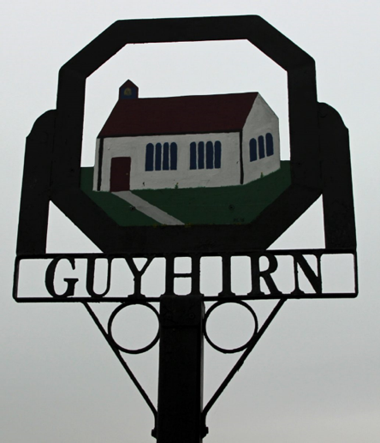
See the accompanying notes for how to change the sample image below.

This quick guide is intended to give you a few pointers to useful information and contacts in the village. For more information see:

Your booklet is just a very brief introductory guide, so do list all the other sources of information in your area. For instance:
- Village/Local Facebook page
- Parish Magazine – when is it delivered? Cost, if applicable.
- Village website address
- Village newsletter – name, how often is it produced, where can people get it?
- Council website address
- Community group at Nextdoor.co.uk, if applicable
- Local (free) newspaper – name, when and where is it available?
- Village noticeboard located….
- Pop into the church/shop for local notices and leaflets

We hope you will be very happy here.
Introducing Click or tap here to enter text.
Give a very brief introduction to the village/town with just a couple of interesting facts. This is not the place to include a full historical account with lists of dates. Think about things that are particularly interesting and give a positive impression, for instance, the meaning of the place name, a famous person who was born or lived there, a link to a quirky annual even etc... Whilst ‘Horrible Histories’ are still popular, avoid mentioning anything too grim even if it is fascinating, for instance, if your village is famous for once having a gallows in a prominent location, best not to highlight it here as it doesn’t give quite the right welcome for new residents.
Example: The name Guyhirn is believed to refer to the control of tidal or salt waters - it has long been an important location in the drainage of the Fens. It is a friendly, quirky village – no shops but we do have a ten-pin bowling centre; near the bustling A47 but with beautiful riverside walks and if you are lucky, you might see our annual visitor, the Guyhirn seal.
Click or tap here to enter text. is in the civil parish of Click or tap here to enter text..

Facilities and Shops
Think about the key things that people need to know about when they are new to an area, using the following headings to group things. Keep the information about each service or facility as brief as possible. An address and contact details are probably enough, but if a description is needed try to limit it to just one sentence. It is best to divide the list of facilities into two sections:
In the Village
List facilities that are located in your village/town, including any mobile services such as a library, fishmonger, butchers etc…

Nearby
List any key facilities that are not located in your village/town. You can also list any desirable facilities if they are in the immediate local area.

Things to include:

Key Facilities:
- Post office
- Post boxes and collection times
- Village stores or newsagent
- Pub
- Fish and chip shop
- Supermarket
- Petrol station
- Garage for MOT, services and repairs
- Schools
- Children’s playground
- Community garden/Village Green
- Parish church – just include name, address and key contact details here (more details further on)
- Other faiths and denominations

Desirable Facilities:
- Restaurant, tea rooms etc…
- Local inn/hotel
- Butchers
- Fishmonger
- Fruit and veg stall
- Farm shop
- Village Hall

Medical
List the nearest:
- Hospital with A&E
- GP surgeries
- Defibrillator
- Pharmacy
- Dentist
- Vets

Transport
Include brief details about:
- Bus routes and bus stops
- Railway station
- Local taxi companies

Other
Include information about anything else you think will be useful, such as:
- Bin collection
- Recycling centre
- Bottle bank, clothes bank etc…
- Domestic Heating Oil suppliers – any village purchase schemes?
- Bottled gas suppliers
- Broadband suppliers
- Mobile signal – are any companies known to give better signal than others?
- Polling station(s)

Entertainment and Leisure
List the nearest:
- Leisure centre
- Swimming pool
- Cinema
- Bowling
- Library/Mobile library (times and locations of stops)/Book swap in an old telephone red box
- Local walks, public footpaths, bridle ways etc…
- Village Green

Societies and Clubs
List things that take place in the immediate local area, including exercise classes. If you have a lot going on, it is best to just write a short paragraph describing the range of things on offer and give details where people can find more information.

Parish Church and Church Hall
This is your chance to promote your church. Keep it brief but highlight the range of things on offer at the church (and church hall if you have one). Include details of when the church building (and church hall) are left open as well as service times. Include information about group activities, family and children activities, concerts and social events at your church. It is also worth highlighting here that it is the PCC who have created the guide.

Example: This guide has been created by the PCC of (Name), a group of volunteers who, amongst other things, look after this beautiful historic church building. The church is usually unlocked each day between about 9am and 4pm and available for anyone to visit. (Church Name) is one of eight churches in the (Name) Benefice. Within the Benefice there is a wide selection of styles of service catering for different people’s preference. We also host numerous community activities throughout the year including Wednesday coffee mornings and the annual Scarecrow Festival. The church can be used for meetings and other public and private events and we welcome new volunteers from all faiths to help us look after the building, run events and raise money.

Church/Benefice Website: insert a web-link

Key Contacts
Include contacts for key things such as:
- Water
- Police (including Community Support Officer)
- Neighbourhood Watch
- Local Council
- Flood Warnings

What’s On
This is where you can list and regular events e.g. annual Village Yard sale, Church Fete, School Bonfire Night, monthly car boot sale etc… Remind people of where they can find information about all events going on in the local area.

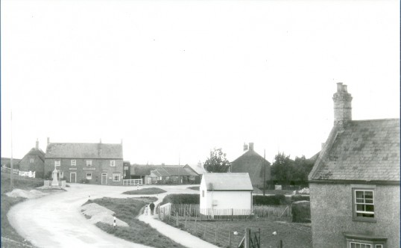

East End of Village. Photo from Wisbech and Fenland Museum.

