Clergy Ministerial Development Review [MDR]

‘Needs’ Questionnaire
To be used in the Year 1 process

Revised June 2023

“Needs” Questionnaire - MDR
(to be used in the Year 1 Ministerial Development Review process)

The Reviewee should please complete and return this form by email to the Mission and Ministry Team as soon as possible: wendy.ivey@elydiocese.org

Name of Reviewee
What is your ‘usual’ rest day?
Are you willing and able to host the MDR? | Yes / No (Delete as appropriate)

We want to ensure that your Ministerial Development Review (MDR) is as helpful as possible and we recognise that how and where the MDR is conducted has an important part to play in achieving that. Even if you answered ‘Yes’ to being able to host the MDR, we ask that all Reviewee’s please also mark their preferences below for where the MDR is held.

 | Answer(s) | Tick all that apply
That the MDR takes place at a venue convenient to the Reviewer? (i.e. such as their home) | YES
 | NO
 | DON’T MIND
That a suitable ‘neutral space’ venue is hired? | YES / NO  (delete as appropriate)

Is there anything that we can provide that will help you access the MDR well?

Our MDR Reviewers are a group of gifted and well-trained clergy and lay individuals that represent the diversity of the Diocese.

Question | Option(s) | Answer (mark your preferred option below)
Would you prefer your MDR to be carried out by (tick the appropriate box) | Someone ordained
 | Someone lay
 | Either is fine

Preparation Form [Year 1] - MDR

Reviewees should please complete this form and email it to their Reviewer two (2) weeks prior to the date set for the Ministerial Development Review (MDR).

Please set aside a significant amount of uninterrupted time to focus on preparing for your MDR.

This document is provided as a guidance to help you identify what you may bring to the MDR conversation. Please do not feel compelled to fill in each box.

Details
Name of Minister (Reviewee)
Role
Date and Place of planned MDR meeting

Context
Please give a brief description of the primary context/s of your ministry, whether parochial, chaplaincy, or other area of employment. It will help your Reviewer to know how long you have been in your current context and if this is your first appointment post-curacy

Current Ministry and Priorities
- What aspects of your ministry have you most enjoyed over the last year - and why? Have there been any changing circumstances in your ministry and context over the past year or so?
What has been most positive, fulfilling, energizing and/or inspiring? What has been important or fulfilling? What has stretched or challenged you?

- What aspects of your ministry have caused you disappointment or frustration and why do you think that is?
What areas of ministry have been unrewarding, daunting, or burdensome? What hindrances have you identified? What skills have been underused? What needs changing?

- What have you been learning over the last year?
What have you been learning about yourself – from experiences or feedback? What have you been learning about God?

- Spiritually – what nurtures and feeds you now?
Spiritually – how is your prayer and what helps?
have you got a spiritual director, cell group or other source of spiritual support?
When did you last take a retreat or time of spiritual refreshment?

- What do you wish you could give more time to?
Personally, spiritually, home-life, in your role as a minister

- What do you need to do for greater balance and health?
Please include one (or more) simple thing and one (or more) radical thing

- How are you supported in your ministry?

- How have you been engaging with Safeguarding?
Keeping training up to date, leading policy implementation, supporting the work of the PSO
- Are there any areas of pressure or conflict in your ministry?
Have you spoken to anyone else about this? Are you accessing any additional resource or support to address these areas?

- Have you got any sense of where God might be calling you in the next few years?

- Reviewing your ‘external perspective’ conversations
What did they affirm? What did they suggest for future focus and personal development?

- How is Ely 2025 enabling/helping you in your role within the parish

- Have you got gifts or interests that you feel you are not able to use fully in your present situation?

- What would be helpful to talk about in the review?
What themes are emerging for you?
Is there a particular issue/challenge that you would appreciate thinking through with a reviewer?

- In a year’s time, how will you know if this review has been helpful?
To you? To your parish/chaplaincy/workplace? To the Diocese? To the kingdom of God?

Preparation Form [Year 2] – MDR

Please complete this form and email to your Year 2 Reviewer 2 weeks prior to the date set for the MDR conversation.

This document is provided to help ensure that the review conversation to be as profitable as possible. Please do not feel compelled to fill each box.

Details
Name of Minister (Reviewee)
Role
Date and Place of planned meeting

Factors that have had a significant impact on progress/development since the Year 1 MDR
Please refer back to the Ministry Development Plan that was created as a result of the Year 1 MDR.
The person carrying out the Year 2 conversation will have access to your Ministry Development Plan.
These factors could be personal or institutional, internal or external. The factors could be positive or negative

What areas would be helpful for the Year 2 MDR conversation to focus on?
These may primarily relate to the Ministry Development Plan.
The areas identified should be focussed on your own ministerial development.
The person carrying out the review may also come with some suggested areas to explore.

Tools to help your Reflection (Year 1) - MDR

Here are three ways which might be helpful – they are optional - use what works for you.

Tool One: Vocational discernment (after St Ignatius of Loyola)
As I look over my ministry this last few years…

- What am I most grateful for?
- What am I least grateful for?
- Where do I come alive?
- Where am I diminished?
- What affirms me in my sense of vocation?
- What undermines my sense of vocation?
- What might God be saying to me now?

Tool Two: Ministry clock - what does flourishing look like?

  - Choose what categories you want to write in the boxes.
  - If 10 is flourishing and 0 is withering, Colour in where you think you are for each segment.
  - Then choose the ones that seem significant and ask yourself ‘what might take me one step further towards flourishing? (Flourishing can be about confidence, resourcing, experience etc.)

The clock below is an example and not meant to be prescriptive – but gives an idea as to what this might look like:

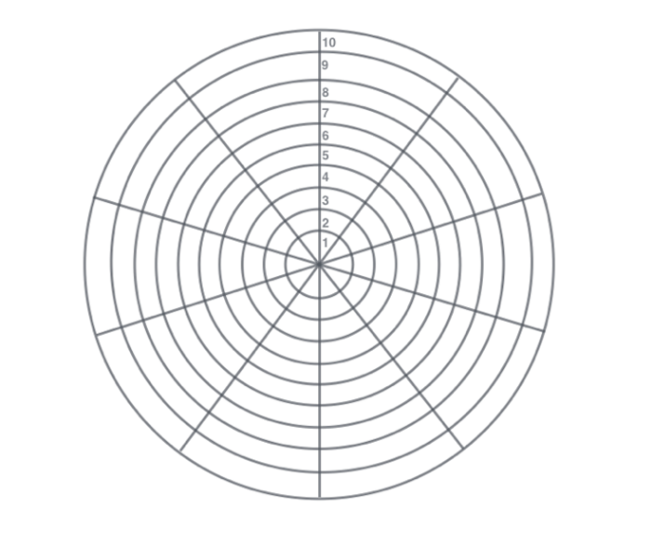
Prayer
School
Pastoral Care
Team meetings
Preaching
Admin and emails
Safeguarding
Project planning
Buildings
Time off/family life

Have a go at the clock on the next page.

Other categories you might want to use could include
- The workplace
- Voluntary work in the community
- Caring responsibilities
- Chaplaincy
- Discernment about a future post
- Involvement in the wider diocese
- Study
- Relationships with colleagues
- Social media
- Supervising staff

My ministry clock - what does flourishing look like for you?

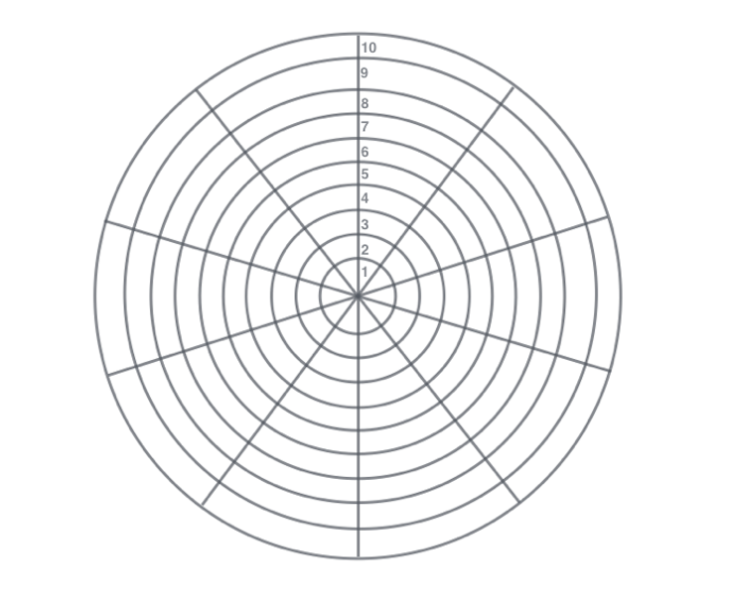

Tool Three: Checklist

As you scan down the checklist, ask yourself:
- What is taking a lot of my attention?
- What is taking a lot of my time?
- What causes me anxiety?
- What makes my heart sing?
- What do I want to give some time and attention to develop?

Item | Your notes
Your primary contexts for ministry – parish or place of work
Other opportunities for engaging in ministry
Worship – seasons, liturgy, and annual cycle
Occasional offices
New services/initiatives
Sermon and teaching
Prayer and spirituality
Parish visiting, supporting collaborative ministry
Church family life
Mission opportunities
Safeguarding
Institutions in the parish – schools, hospitals, and so on
Church presence locally
Administration, diary management, telephone/IT, office
Parish planning
Deanery or other roles, meetings, chapters etc
Diocesan, regional, or national roles

Other Perspectives [Year 1] - MDR

The MDR process involves a guided discussion around the ministry of a licensed minister.

The purpose of the MDR is to reflect on what has happened over the past two years of ministry, to begin to discern what may lie ahead in which future objectives and areas for development can be identified.

With the Ely Diocese MDR process, clergy are asked to identify three people who are invited by the priest to offer feedback as part of the MDR process.

It is recommended that one of the three would be a Churchwarden for a priest involved in parochial ministry and can also include someone from the wider community.

It is recommended for those serving in a team then one of the ‘other perspectives’ would be a Team Rector if you are a Team Vicar or a Team Vicar if you are a Team Rector.

Those giving feedback should not be a family member or close personal friend.
The priest will make contact to arrange an opportunity to have a conversation with each person.

The role of this feedback is to offer a within-context perspective in order to help the priest reflect on their ministry.

It takes the form of a conversation and should focus around two main questions:

- What has gone well in this person’s ministry in the last year or two?
- What might be the principal areas for future focus and personal development?

During the conversation, the person giving feedback is encouraged to:

- pay attention to the priest’s ministerial skills, knowledge, and relationships.
- be affirming and encouraging as well as appropriately challenging, exploring where there might be opportunities for growth and development.
- identify strengths that might be made more widely available.
- keep the conversation confidential.
- Keep the feedback short and manageable.

After the conversation, the priest writes a concise summary of what has been discussed (bullet points are ideal).

On the paperwork they submit for their MDR the priest is asked to reflect on what has emerged from these conversations.

Nothing will be attributed to a named person and no notes from the conversations will be passed to anyone else involved in the MDR.

Other Perspectives Feedback Form

Name of Minister

Question | Answer
1. What particular areas of the individual’s ministry do you feel able to comment on?

2. What do you think are the gifts and strengths of the minister?

3. Where might the individual’s ministry need to grow and change?

4. How does the individual manage time, for example, between their various ministerial commitments and time for rest and relaxation?

5. Have you other comments that would be helpful in preparation for the individual’s Ministerial Development Review?

Ministry Development Plan - Example

Name (Reviewee) |  | Date of Review
Name (Reviewer) |  | Date of Plan

Changes and Developments I want to see | Changes that need to happen | Training and what will you do to achieve this? | Learning with and from others and what will you do to achieve this? | Learning through experience  and what will you do to achieve this? | What should be different in 12-18 months
Church Warden about to retire, lack of lay leaders in the parish – new vocations and new ministries needed | Build relationships  Build confidence  Identify potential  Change my approach  Build culture of appreciation and gratitude | Course in Appreciative Inquiry, coaching or growing lay leaders | Identify partners, eg. Ministry team, deanery colleagues, others from course to reflect with – plan to meet 2 or 3 times in 18 months | Review culture of PCC  Identify potential leaders and build relationships  ? include review in APCM  ? Ask congregation how they feel | More volunteers  Current volunteers more confident people
A better work/life balance, renewed joy in prayer and worship | Help to address issues  Time set aside to solve problems  New skills / people to talk to | Course in Time Management or Clergy Wellbeing | Pastoral Reflection Group, Cell Group, Spiritual Director | Diary management  Retreat and holiday  Take up a hobby  Make time to enjoy sport / walking | Congregation and family notice the difference in me, I feel renewed in ministry and ready for the next five years.
I want more confidence in leadership and project management | Acquire new skills  Know what is involved in building project  Identify allies in parish | Internet research or find lay person with project management skills | Mentor or Work consultant, consult diocese and DAC | Build team, establish time line, include time to plan/do/reflect  Ask for feedback | Building project underway and everyone confident in management, not too many distractions

Ministry Development Plan - Template
Please note that only resources identified in this Ministry Development Plan will be eligible for CMD funding and many resources may be available through the Diocese. If you would like a conversation about your development plan, please contact the Deputy Director of Mission and Ministry (peter.leech@elydiocese.org)

Name (Reviewee) |  |  |  | Date of Review
Name (Reviewer) |  |  |  | Date of Plan
Changes and Developments I want to see  (identified through MDR conversation) | Changes that need to happen  (identified through MDR conversation) | Training and what will you do to achieve this? | Learning with and from others and what will you do to achieve this? |  | Learning through experience  and what will you do to achieve this? |  | What should be different in 12-18 months  (Identified through MDR conversation)

