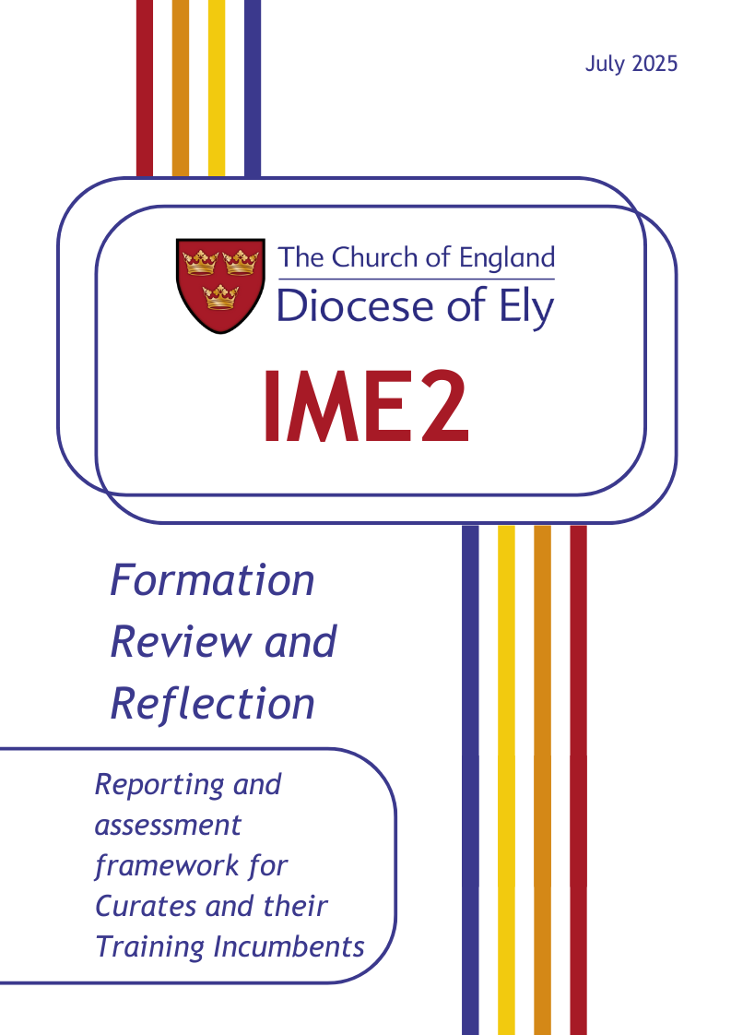
Formation Review and Reflection Form
Name of Curate
Name of Training Incumbent
Benefice/Parish
Stage of curacy | End of yr 1 Mid-curacy update  End of yr 2 Update for sign off
Date
Curate’s signature
TI’s signature
An electronic signature will suffice
Banding
7 | Inhabits all aspects of the quality to a depth that significantly exceeds what might be expected at this stage of development.
6 | Inhabits all aspects of the quality very well and may inhabit some aspects in a way that exceeds what might be expected at this stage of development.
5 | Inhabits all aspects of the quality competently and comfortably and in a way that is commensurate with this stage of development.
4 | Inhabits most aspects of the quality reasonably well, though there may be limitations in some areas, lack of depth, or gaps in understanding that IME2 still needs to address
3 | Does not inhabit significant aspects of the quality sufficiently and intervention is required
2 | Does not inhabit the quality in most respects and significant intervention is required.
1 | There are causes for concern which need immediate attention.

Remember to have the IME2 qualities and evidence framework in front of you as you write your reflections, ensuring you write to the suggested evidence:
ime-2-priest-qualities-and-evidence-from-autumn-2022.pdf
Love for God
Band:
Curate Comments and Reflection:
Please ensure you write across all four domains (Christ, Church, World, Self).

Training Incumbent Comments:

Call to Ministry
Band:
Curate Comments and Reflection:
Please ensure you write across all four domains (Christ, Church, World, Self).

Training Incumbent Comments:

Love for People
Band:
Curate Comments and Reflection:
Please ensure you write across all four domains (Christ, Church, World, Self).

Training Incumbent Comments:

Wisdom
Band:
Curate Comments and Reflection:
Please ensure you write across all four domains (Christ, Church, World, Self).

Training Incumbent Comments:

Fruitfulness
Band:
Curate Comments and Reflection:
Please ensure you write across all four domains (Christ, Church, World, Self).

Training Incumbent Comments:

Potential
Band:
Curate Comments and Reflection:
Please ensure you write across all four domains (Christ, Church, World, Self).

Training Incumbent Comments:

Trustworthiness
Band:
Curate Comments and Reflection:
Please ensure you write across all four domains (Christ, Church, World, Self).

Training Incumbent Comments:

