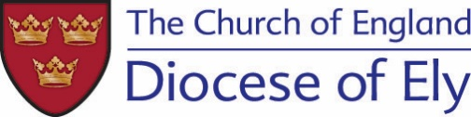

In line with Government Public Health advice the Ely Diocesan Offices have been closed until further notice.

The Safeguarding Team all continue to work as usual, but remotely. All team members have access to emails and are available on their mobile telephone numbers. All contact details are listed below for your convenience.

All safeguarding referrals and requests for advice and support relating to safeguarding should continue as usual.

The Safeguarding Team are preparing Safeguarding Frequently Asked Questions in relation to Safeguarding Training, Disclosure and Barring Service Checks and Parish and Community Initiatives in relation to Coronavirus (Covid-19). This information will be published over the coming days.

Safeguarding Duty Phone: 01353 652747 (Please do not use this number for queries about DBS checks, training or recruitment issues)

Diocesan Safeguarding Adviser: Rebecca Boswell

Hours of work 9am-5pm Monday to Friday
Email: rebecca.boswell@elydiocese.org
Mobile No: 07904 487912

Assistant Diocesan Safeguarding Adviser: Sharon Gage (part-time)

Hours of work 9.30am-2pm Monday to Thursday
E-mail: sharon.gage@elydiocese.org
Mobile No: 07507 741295

Assistant Diocesan Safeguarding Adviser: Lisa Pearson (part-time)

Hours of work 9am-3pm Monday to Thursday
E-mail: lisa.pearson@elydiocese.org
Mobile No: 07990 581267

Training, Criminal Record Checks and Parish Safeguarding Officer Support

Diocesan Safeguarding Officer- Sarah King

Hours of work 9am-5pm Monday to Friday
E-mail: sarah.king@elydiocese.org
Mobile No: 07776 661798

Safeguarding Administrative Support - DBS checks: Jackie Cox (part-time)

Hours of work 9am-5pm Tuesday and Wednesday
E-mail: safeguardadmin@elydiocese.org

Safeguarding Administrative Support - Training: Kelly Nott (part-time)

Hours of work 10am-2pm Monday to Friday
E-mail: safeguarding.training@elydiocese.org

