A Very Warm Welcome to
Click or tap here to enter text.

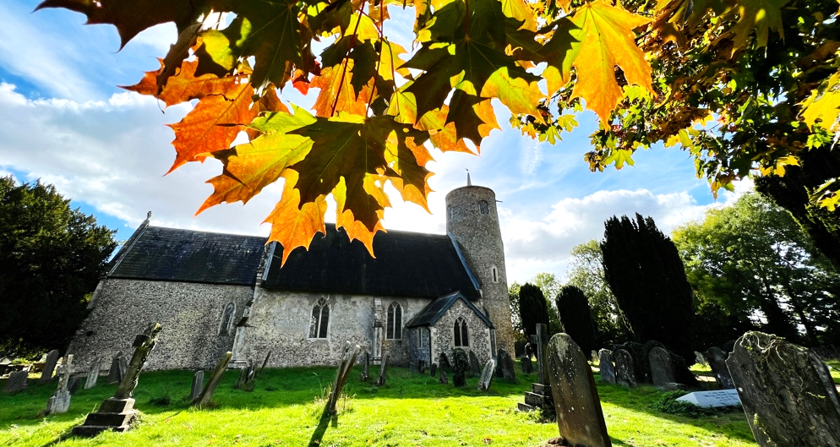
See the accompanying notes for how to change the sample image above.

Thank you for visiting Church Name today!
Please take this leaflet with you as you explore the architecture and history of this beautiful church. The leaflet points you to the special treasures and features of the church building and its treasures accumulated over hundreds of years.
We hope you will find something special here.

Below are some of prompts (from various REACH Ely case studies) to help you write the guide. You may want to begin with description of the church location and the south or north porches with the entrance. Provide interesting facts and avoid full historical details. The opening should briefly introduce visitors to the site of the church, period of construction and special features of the building.
The church overlooks the largest village green…
The present location of the church was set…
The church was built in the architectural style of…
The exact origins of the church are unknown, however the Saxon grave slabs and fragments of a cross embedded in the east wall of the church show that people have worshipped on the site for over a thousand years…
A clock, widely known because of Rupert Brooke’s poem, was installed in 1870 or 1877.
The current church tower was partly rebuilt with brick after the Reformation…
The nave features a thatched roof – a rarity in churches of this period…

As you guide visitors through the church entrance, tell more about what they might see first.
When entering the church, notice the eclectic blend of Victorian and medieval architectural styles. These are seen in…
The door and the arch features…
Admire the handsome 18th-century font with leafy carving, placed near the entrance…

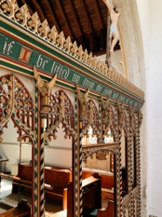
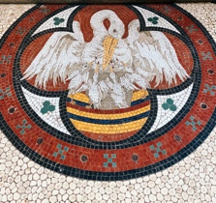

The iron-bound parish chest is believed to be used…
The nave and aisles are Perpendicular…
The organ, built in 1851, was restored at the end of the 20th century…
Notice a fine mosaic of a pelican – a reference to Christ and a symbol of self-sacrifice…

Proceed with some details in the nave. There are certainly a lot to tell, but be brief.
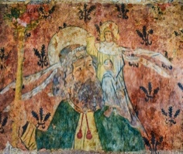
When entering the church, notice the blend of Victorian and medieval styles…
The bell chamber contains…
Look above: you can see a splendid array of wood carved angels…
Several wall paintings include 14th-century scenes from the Resurrection and remains of floral decoration.
The War memorial on the south wall…
A number of pews originating from around the 16th century with carved ends and finials…
Only a few pieces of stained glass remain, but there are some nice medieval fragments in the east window of the south aisle…
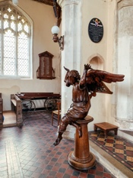
The East window is a memorial to Dr John Wright, surgeon, who must have been much admired by the donors…
A prominent feature is the Angel Lectern, carved in oak with extended wings, holding the book-rest, was described by architectural historian Nikolaus Pevsner.

Lead your visitors toward the chancel and High Altar.
The well-lit chancel – an example of the Decorated period – may have been the work of craftsmen from the Lady Chapel workshop at Ely…

The chancel rood screen dates from the 15th or early 16th century with much original woodwork…
Walk around and notice floor plaques of…
Closer inspection of the rood screen reveals little faces and pinnacles decorations…
The chancel floor has the brass in memory of William Knight, Rector 1599–1623.
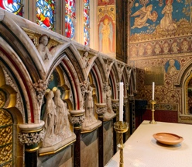
The choir stalls…The Sing Papworth choir usually gives a concert every year in the church…
How many Saints can you count? Inspect the alabaster panelling in the sanctuary, inlaid behind the altar with figures of saints in mosaic, influenced by the Oxford movement…

A few more details and closing remarks.
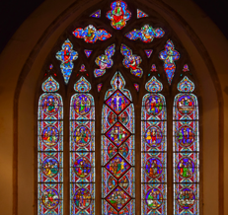
The stained glass windows, said to be East Anglia’s largest expanse of 19th century French cathedral glass, depict scriptural scenes, mainly from the New Testament…
The church hall is used for church events such as Sunday school, Pathfinders, Friday evening youth club, as well as various events by local community groups…
…
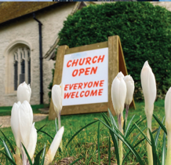
This church is open daily and provides a needed place of peace, reflection and private prayer. We offer various events and activities and services. Visit us (your church website) and follow on social media.
Insert additional pages if needed.
We hope you visit us again!

Sample photos source: REACH Ely case studies.

